Simple circuit creation on Logisim simulator

John F. Wakerly – Digital Design. 4th edition. Chapter 4.

- Goal – Teach students the Logisim simulator and how to create the circuit, analyze and simulate.
- Learning outcome - by the end of this class the students should be able to create a schematic of any simple Boolean function on Logisim and do functional simulation.

To start to work with the schematics we need a simple tool. I suggest to use either the Logicly or Logisim logical circuit simulators. They are free tools, very comfortable and do not need complex installation.

Download the tool:

I suggest to download the logisim-win-2.7.1.exe from the Sourceforge.net by this link http://sourceforge.net/projects/circuit/

At the time this handout is created the latest version of Logisim was 2.7.1. You can choose the new version if it appears on the site.

Installation:

No installation is needed for this tool. Just run the file you have downloaded - logisim-win-2.7.1.exe.

Starting to use:

After running the tool you see this screen:

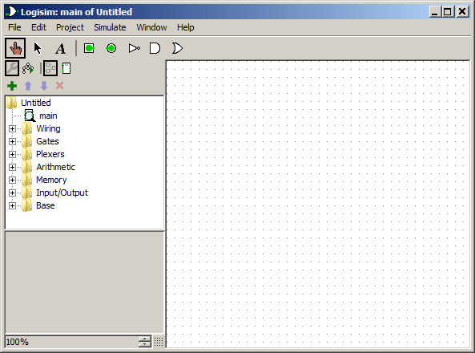

The large white area to the right is the place where you should draw your schematic. The elements you should use for schematic creation are on the left tree of items.

For circuit creation you can use the tutorial from the server “04 The Guide to Being a Logisim User.pdf “. The same document you can find also on the web page http://www.cburch.com/logisim/docs/2.3.0/guide/

To learn how to work on the Logisim simulator create 2 schematics for 2NAND and 2NOR elements.

Use inputs to control the signal values and appropriate output devices, leds to show the signal values. On below examples you can see how I used the inputs and outputs on different schematics.

